**Business Insights**

The Sales data for the entire year of an electronics company has been analyzed and below are the insights that are drawn from the data.

**Insight #1.**

**Objective: -** To understand which month had the highest sale and months with lower sale and try to estimate the reason behind it.

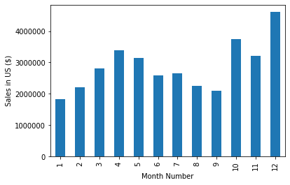

**Month Number corresponds to months in order. 1 is for January, 2 is for feb and so on**

The above graph clearly shows that max sales was made in December month. This may be due to the fact that it is the festival season with holidays such as Christmas, thanks giving, new year eve. Most of the people enjoy the discounts given on electronic products.

Total sale made in December: **4,613,443.34 $**

Also, January and September saw the lowest sales. This can be due to the fact that every one starts their jobs back in January and after spending much in December, people start saving for the year to come. Similarly, people might be saving up in September so as to spend during the festival season in November and December.

**Recommendations:**

* Company must put more efforts in December month to deliver better customer service, discounts and combo offers. This is the time when customers are out to spend money and a better advertisement and discounts will push the sales even higher.
* To boost sales in January and September, better EMI and finance options can be explored. Along with that increased warranty and a promise to deliver better customer service along with increased advertising can increase the sales.

**Insight #2:**

**Objectives:** Finding out which city had the highest number of sales.

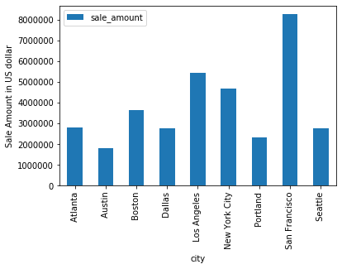

It’s no wonder San Francisco has the highest sales. San Francisco has Silicon Valley and other IT hubs. Many individuals and companies buy electronic items like MacBook, television and other small electronic items.

Total sale done in San Francisco in a year = **8,262,203.91 $**

Also, small cities like Austin, Portland had less sales. This is because these cities have a smaller number of IT companies and have mainly manufacturing and service industries.

**Recommendations:**

* In San Francisco, we can remove discounts on individual items as they are already getting sold and give discounts on items purchased in combination. For example, if a person buys a lightning charge cable along with the phone, he can get addition 10-15% off on the cable.
* For cities like Austin and Portland, company should focus on selling more handy items likes phones, cables, ear pieces etc. and impose better EMI and finance facilities. Also, a better customer service and giving longer warranty will help encourage the customer to buy more electronics.

**Insight #3:**

**Objective: -** what is the best time of the day to display advertisement to maximize the likelihood of customers buying products.

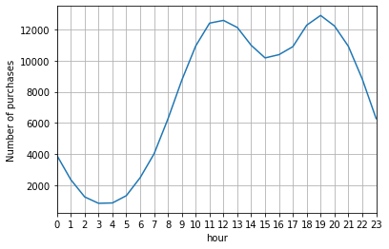

The above graph shows that the sales are very less during midnights and after 11 pm. The actual buying starts from 10 am and at 6 pm in the evening. These are the time when the stores enjoy maximum foot fall.

**Recommendations:**

* Any kind of social event advertisement or any video advertisement should be done between 10am-2 pm and from 5 pm to 9 pm instead of all-day advertisement. These time slots attract maximum customers and the chances of ad converting to sales will be maximum.

**Insight #4**

**Objective: -** we are interested in knowing what products are mostly sold together?

|  |  |
| --- | --- |
| **Products** | **Number of times purchased together** |
| iPhone and Lightning Charging Cable | 2140 |
| Google Phone and USB-C Charging Cable | 2116 |
| iPhone and Wired Headphones | 987 |
| Google Phone, Wired Headphones | 949 |
| iPhone and Apple Airpods Headphones | 799 |
| Vareebadd Phone and USB-C Charging Cable | 773 |

The above table shows two products that are frequently brought together.

|  |  |
| --- | --- |
| **Products** | **Number of times purchased together** |
| Google Phone, USB-C Charging Cable and Wired Headphones | 271 |
| iPhone, Lightning Charging Cable and Wired Headphones | 193 |
| iPhone, Lightning Charging Cable and Apple Airpods Headphones | 146 |
| Google Phone, USB-C Charging Cable, Bose SoundSport Headphones | 109 |
| Vareebadd Phone, USB-C Charging Cable and Wired Headphones | 101 |

The above table shows three products that are frequently brought together.

We can clearly see in the above table that mostly phone, charging cables and ear phones/head phones are usually brought together.

**Recommendations:**

* We should always keep phones, charging cables and headphones/air pods/ear phones near to each other.
* Also, we should provide some discount if the products are brought together.
* Further more a sales executive can be instructed to advice the customer for best cables and ear sets that suits the phone.

**Insight #5**

**Objective: -** what product was sold the most and why?

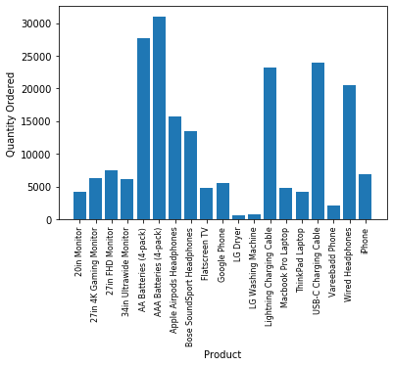

The above graph shows that Batteries, charging cables and headsets are sold a lot compared to other items. This is because these products are comparatively cheaper and gets exhausted or damaged soon. However, below graph shows better details.

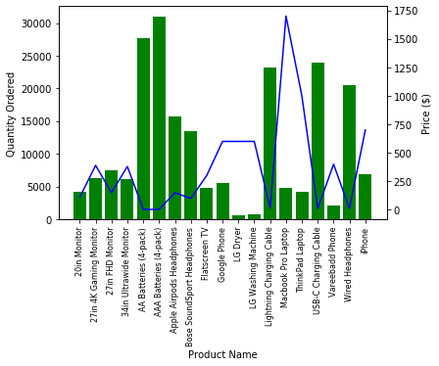

The blue line shows the price of each item and green bars how’s the quantity purchased. Most of the time the items with less prices are sold a lot. However, there is an exception with laptops. Even though they are the costliest still they are sold more than the items like dryer, washing machines or monitors. This can be due to the fact that laptops are required by almost everyone, from a student to working professionals.

**Recommendations:**

* The company must always maintain stock for cheap items as they are highest selling.
* The company must provide highest level of customer service for the laptop segment to maintain the sale of laptops. A student discount can be given for outdated or low specs laptops.
* Dryers, monitors, tv sales can be increased by giving better EMI and finance options, increasing the warranty and giving more discounts.